**PIZZA SALES SQL QUERIES**

**A. KPI’s**

**1. Total Revenue:**

select sum(total_price) as Total_revenue from pizza_sales;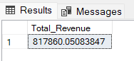

**2. Average Order Value**

SELECT (SUM(total_price) / COUNT(DISTINCT order_id)) AS Avg_order_Value FROM pizza_sales;

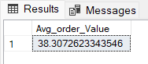

**3. Total Pizzas Sold**

SELECT SUM(quantity) AS Total_pizza_sold FROM pizza_sales;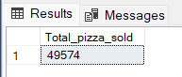

**4. Total Orders**

SELECT SUM(quantity) AS Total_pizza_sold FROM pizza_sales;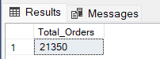

**5. Average Pizzas Per Order**

SELECT CAST(CAST(SUM(quantity) AS DECIMAL(10,2)) / CAST(COUNT(DISTINCT order_id) AS DECIMAL(10,2)) AS DECIMAL(10,2))

AS Avg_Pizzas_per_order

FROM pizza_sales;

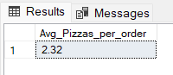

**B. Daily Trend for Total Orders**SELECT dayname(order_date) AS order_day, COUNT(DISTINCT order_id) AS total_orders FROM pizza_sales

GROUP BY dayname(order_date);

***Output:***

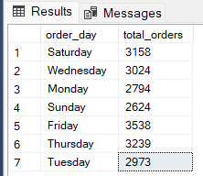

**C. Monthly Trend for Orders**

select monthname(order_date) as Month_Name, COUNT(DISTINCT order_id) as Total_Orders from pizza_sales

GROUP BY monthname(order_date);

***Output***

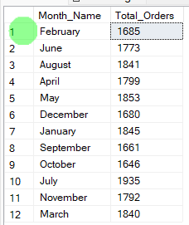

**D. % of Sales by Pizza Category**

SELECT pizza_category, CAST(SUM(total_price) AS DECIMAL(10,2)) as total_revenue, CAST(SUM(total_price) * 100 / (SELECT SUM(total_price) from pizza_sales) AS DECIMAL(10,2)) AS PCT FROM pizza_sales

GROUP BY pizza_category;

***Output***

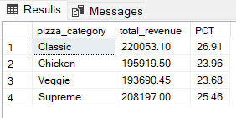

**E. % of Sales by Pizza Size**

SELECT pizza_size, CAST(SUM(total_price) AS DECIMAL(10,2)) as total_revenue, CAST(SUM(total_price) * 100 / (SELECT SUM(total_price) from pizza_sales) AS DECIMAL(10,2)) AS PCT FROM pizza_sales

GROUP BY pizza_size

ORDER BY pizza_size;

***Output***

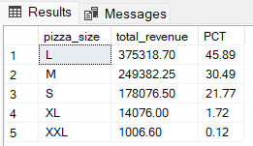

**F. Total Pizzas Sold by Pizza Category**

SELECT pizza_category, SUM(quantity) as Total_Quantity_Sold

FROM pizza_sales

GROUP BY pizza_category

ORDER BY Total_Quantity_Sold DESC;

***Output***

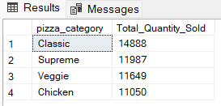

**G. Top 5 Pizzas by Revenue**

SELECT pizza_name, SUM(total_price) AS Total_Revenue

FROM pizza_sales

GROUP BY pizza_name

ORDER BY Total_Revenue DESC

limit 5;

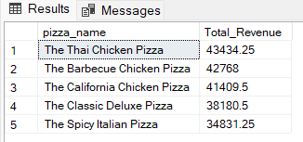

**H. Bottom 5 Pizzas by Revenue**

SELECT pizza_name, SUM(total_price) AS Total_Revenue

FROM pizza_sales

GROUP BY pizza_name

ORDER BY Total_Revenue asc

limit 5;

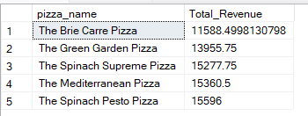

**I. Top 5 Pizzas by Quantity**

SELECT pizza_name, SUM(quantity) AS Total_Pizza_Sold

FROM pizza_sales

GROUP BY pizza_name

ORDER BY Total_Pizza_Sold DESC

limit 5;

***Output***

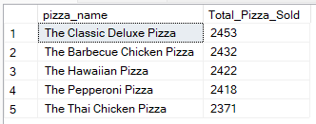

**J. Bottom 5 Pizzas by Quantity**

SELECT pizza_name, SUM(quantity) AS Total_Pizza_Sold

FROM pizza_sales

GROUP BY pizza_name

ORDER BY Total_Pizza_Sold asc

limit 5;

***Output***

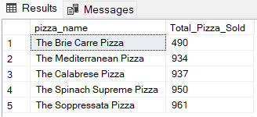

**K. Top 5 Pizzas by Total Orders**

SELECT pizza_name, COUNT(DISTINCT order_id) AS Total_Orders

FROM pizza_sales

GROUP BY pizza_name

ORDER BY Total_Orders DESC

limit 5;

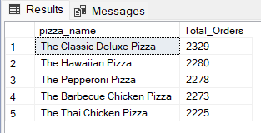

**L. Bottom 5 Pizzas by Total Orders**

SELECT pizza_name, COUNT(DISTINCT order_id) AS Total_Orders

FROM pizza_sales

GROUP BY pizza_name

ORDER BY Total_Orders asc

limit 5;

